Array & Object Programs

**Squares of a Sorted Array**

**Solution**

Given an integer array nums sorted in **non-decreasing** order, return *an array of****the squares of each number****sorted in non-decreasing order*.

**Example 1:**

**Input:** nums = [-4,-1,0,3,10]

**Output:** [0,1,9,16,100]

**Explanation:** After squaring, the array becomes [16,1,0,9,100].

After sorting, it becomes [0,1,9,16,100].

**Example 2:**

**Input:** nums = [-7,-3,2,3,11]

**Output:** [4,9,9,49,121]

Solution:

function sortedSquares(nums) {

let arr = [];

// Square each number and add to arr

for (let i = 0; i < nums.length; i++) {

arr[i] = nums[i] * nums[i];

}

// Sort the array in ascending order

for (let i = 0; i < arr.length - 1; i++) {

for (let j = i + 1; j < arr.length; j++) {

if (arr[j] < arr[i]) {

// Swap elements if they are out of order

let temp = arr[i];

arr[i] = arr[j];

arr[j] = temp;

}

}

}

return arr;

}

**2.Find All Numbers Disappeared in an Array**

**Solution**

Given an array nums of n integers where nums[i] is in the range [1, n], return *an array of all the integers in the range* [1, n] *that do not appear in* nums.

**Example 1:**

**Input:** nums = [4,3,2,7,8,2,3,1]

**Output:** [5,6]

**Solution:**

function findDisappearedNumbers (nums) {

let res = [];

for(let i = 1; i<=nums.length; i++){

if(nums.indexOf(i)==-1){

res.push(i);

}

}

return res

};

**Valid Mountain Array**

**Solution**

Given an array of integers arr, return *true if and only if it is a valid mountain array*.

Recall that arr is a mountain array if and only if:

**Valid Mountain Array**

**Solution**

Given an array of integers arr, return *true if and only if it is a valid mountain array*.

Recall that arr is a mountain array if and only if:

function isValidMountainArray(arr) {

if (arr.length < 3) {

return false;

}

let i = 0;

while (i < arr.length - 1 && arr[i] < arr[i + 1]) {

i++;

}

if (i == 0 || i == arr.length - 1) {

return false;

}

while (i < arr.length - 1 && arr[i] > arr[i + 1]) {

i++;

}

return i == arr.length - 1;

}

Second Solution:

var validMountainArray = function(arr) {

let i = 0;

let j = arr.length - 1;

let n = arr.length - 1;

while (i + 1 < n && arr[i] < arr[i+1]) {

i++;

}

while (j > 0 && arr[j] < arr[j-1]) {

j--;

}

return (i > 0 && i == j && j < n);

}

Output:

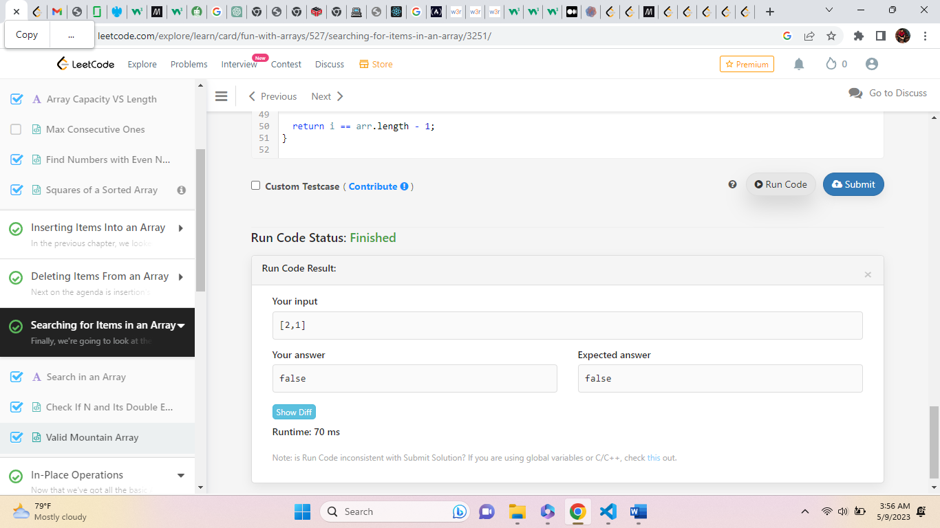

Write a program to print given Array?

["Alcazar", "Volvo", "BMW"];

[22, 23, 24, 24]

function Arr(){

    const cars = ["Alcazar", "Volvo", "BMW"];

    const num = [22, 23, 24, 24]

    let result1= cars;

    let result2 = num;

    console.log('result1', result1)

    console.log('result2', result2)

1

return (

    <div>

        {result1}<br/>

        {result2}<br/>

    </div>

);

}

export default Arr;

Write a program to print given array?

names = ["Pooja", "Mansi", "Hanika"];

num=[56, 67, 89, 78, 89, 90, 100, 65, 89, 90]

function Arr(){

    const names = ["Pooja", "Mansi", "Hanika"];

    const num=[56, 67, 89, 78, 89, 90, 100, 65, 89, 90]

     let result= [names, num];

     console.log("result", result)

    return (

        result.map(ele => {

            return(

                <div>

                {ele} <br/>

                </div>

            )

            })

      </div>

      );

          }

          export default Arr;

Objects Programs:

Write a program to print first name and eyecolor from given object?

function Myfun() {

    let result = {}

    const person = {

        firstName: "John",

        lastName: "Doe",

        age: 50,

        eyeColor: "blue"

    };

    console.log(person.firstName +  person.eyeColor)

    return (

                <div>

                    {result}

                </div>

    );

}

export default Myfun()

function Myfun() {

    let result;

    const person = {

        firstName: "Pooja",

        lastName: "Savant",

        age: 24,

        eyeColor: "blue",

    };

     result= (person.firstName)

    console.log(`${person.firstName} ${person.lastName}`)

    return (

                <div>

                    {result}

                </div>

    );

}

export default Myfun()

function Myfun(){

const courses = [

    {

    id: 0,

    name: 'Full Stack Developement Program',

    price: '89,999',

    category: 'Software Developmen',

  },

  {

    id: 1,

    name: 'Python Automation Testing Program',

    price: '64,999',

    category: 'Testing',

  },

  {

    id: 2,

    name: 'UI/UX Program',

    price: '89,999',

    category: 'design'

  }

]

 console.log(courses)

  return (

    <div>

    <ul>{courses}</ul>

    </div>

  );

}

export default Myfun;

function Myfun(){

  let result={}

const course =

    {

    id: 89,

    name: 'Full Stack Developement Program',

    price: '89,999',

    category: 'Software Development',

  }

result= (course.id)

console.log(course['name'])

  return (

    <div>

     {result}

    </div>

  );

}

export default Myfun;